in co-operation with

>>> Call for Papers <<<

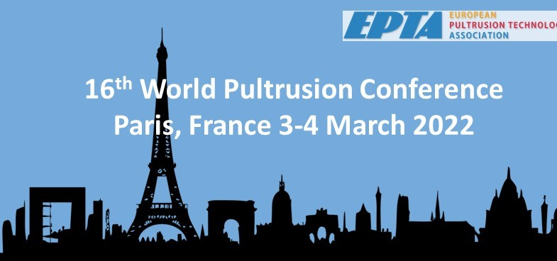

Picture source: https://pixabay.com
Be part of one of the leading pultrusion events
in the world!
– More information www.pultruders.com –

SPEAKERS APPLICATION FORM
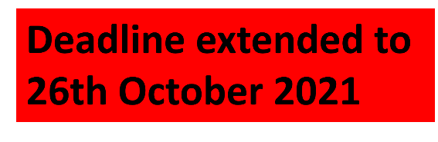
16th WORLD PULTRUSION CONFERENCE 2022
[3 – 4 March 2022 in Paris]

Please return by 15th October 2021 at the latest!

EPTA – European Pultrusion Technology Association
Dr. Elmar Witten
Am Hauptbahnhof 10

60329 Frankfurt
info@pultruders.com

Name of the speaker:
Title and position:

Company/Institution:

Address:

Phone-no./mobile:
E-mail:

Title of presentation:

Informative abstract (appr. ½ DIN A4 page)

